Check Processing PO
The Check Processing - PO tab is used to post a transaction for a computer check or to post a district check for an existing purchase order. When posting a check for a purchase order, the system automatically updates the general ledger’s expenditure, 4310 reserves for encumbrance, and the contra accounts. The system also updates the outstanding purchase order and vendor files.

Fifteen transactions can be placed on a single vendor check before the transactions flow over to the next check. The totals are displayed on the last check to that vendor. All previous checks are then voided by the system.

___ 1 Finance>Maintenance>Postings>Check Processing PO… VERIFY THE ACCOUNTING PERIOD YOU ARE IN!
In the transaction section, select an existing PO. The system displays the transaction details for the PO in the detail section and the transaction summary for the PO in the summary section.

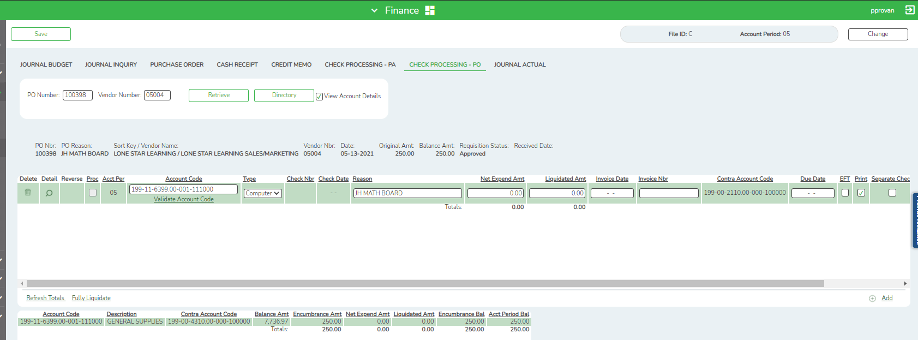

___ 2 The Proc field is selected if the PO has not been fully liquidated (a check has been issued but an encumbrance balance exists) and the transaction has been through end-of-month processing. The field is not selected if the PO is unprocessed.

The Acct Per field displays the accounting period for this transaction. The field is display only.

The Account Code field is automatically populated when the user selects a specific purchase order from the transaction section. The check transactions that are automatically created are based on the amount available for the accounting period, which is displayed in the Acct Period Bal field (in the summary section) and must be greater than zero. For example, when a purchase order has been created in the next accounting period, and the user is in the current accounting period, the Acct Period Bal field should be zero and the Account Code drop down will be blank. The user should log into the next accounting period to post to this PO.

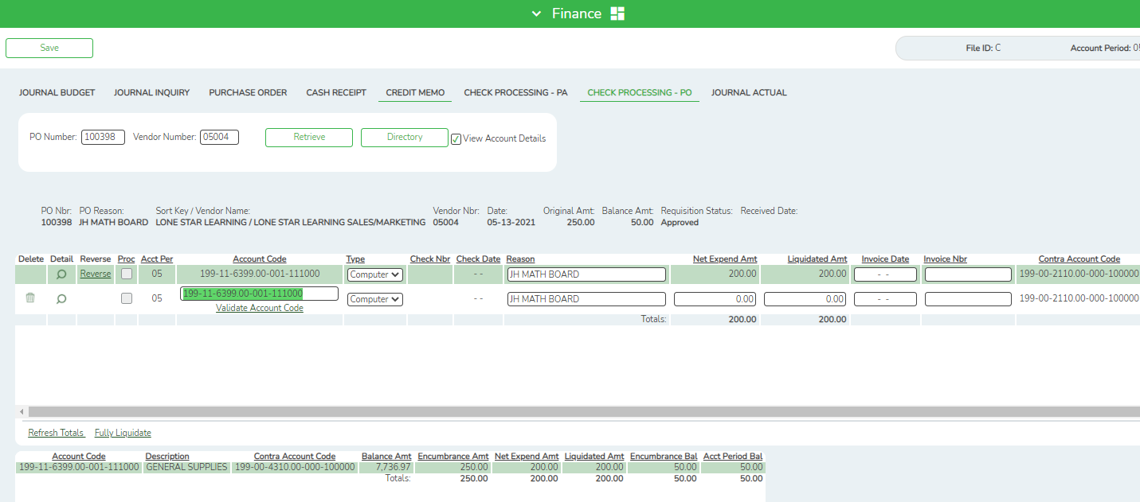

___ 3 In the Type field, click the dropdown to select either computer or district check. The following table shows which fields are required depending on the selection in the Type field.

Field to Fill In | Computer | District
Check Nbr | No | Yes
Date | No | Yes
Reason | No | No
Invoice Date | No | No
Invoice Nbr | No | No
Print | Yes | No
Trans Date | Yes | Yes
Contra | No | Yes
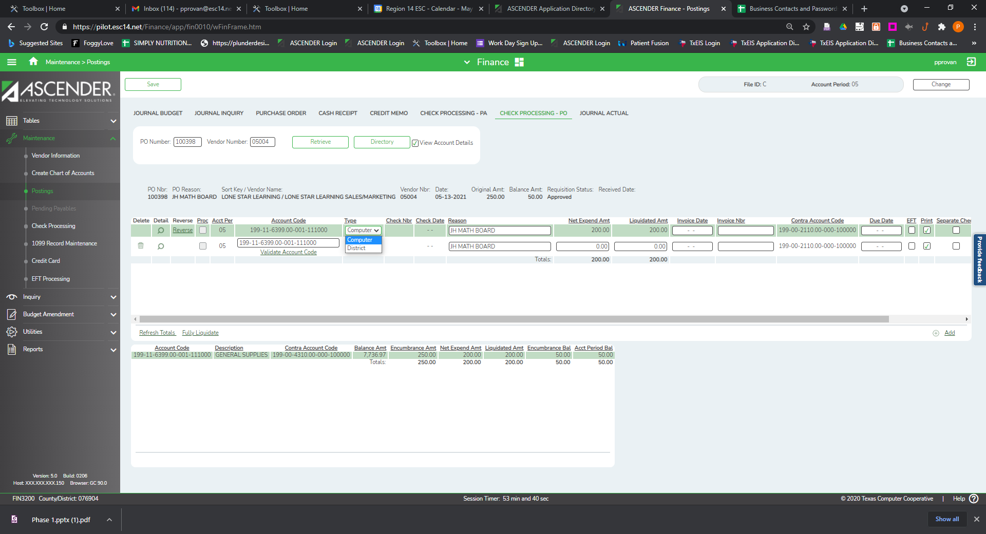

___ 4 The Check Nbr field is enabled only if the user selects District as the check type to be issued. This is a user-defined, six-digit field. The field does not have to be zero-filled, so the user can enter one or more digits.
Notes:
- The system validates the check numbers for district checks and displays a message if the user enters a duplicate check number.
- Once a deferred check is printed, the check number description will display "PAYABL" in the expenditure account. The numerical check number is displayed in the accounts payable account for the accounting period in which the check was printed.
- The Check Date field is enabled only after the user selects District as the check type to be issued. Type the date the district check is issued.

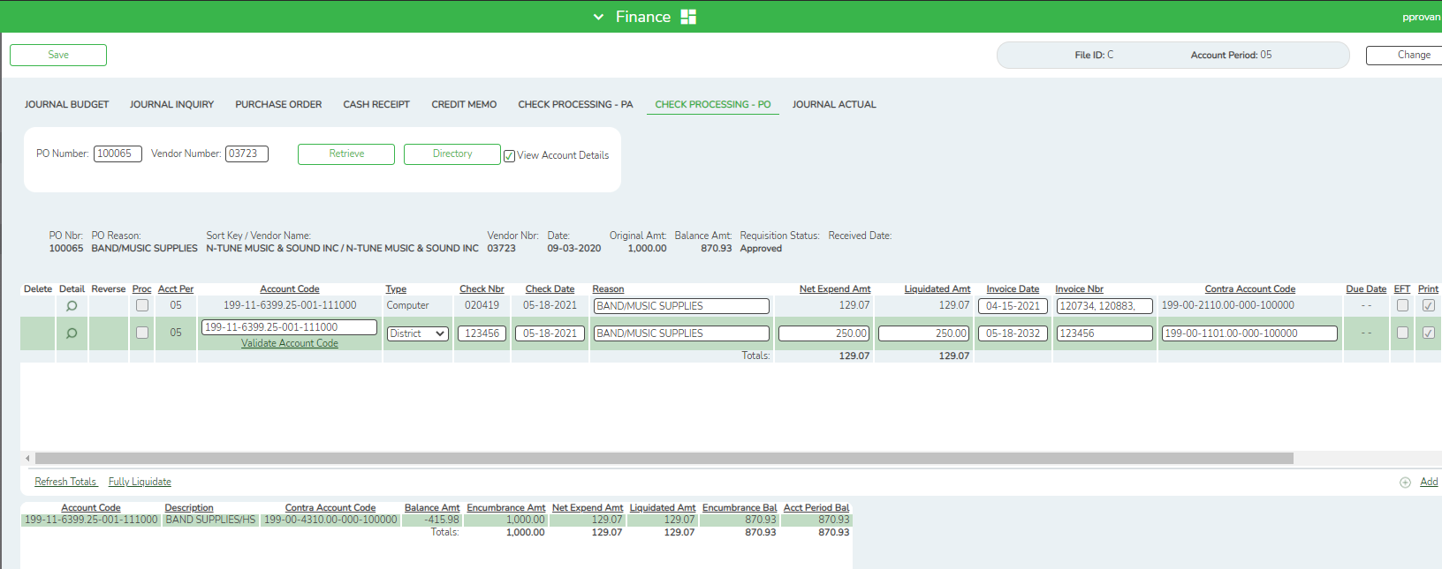

___ 5 In the Reason field, type a user-defined reason for the transaction. The field can be a maximum of 30-characters.

___ 6 In the Net Expend Amt field, enter an amount for this check transaction.

___ 7 In the Liquidated Amt field, enter an amount to be liquidated for this check transaction, typically the same as the Net Expenditure amount. The amount defaults to zero and displays a warning if nothing is entered.

The Fully Liquidate link in the bottom left corner of the grid applies to the selected purchase order only. If the Fully Liquidate link is selected, the Liquidated Amt field is populated with the full Encumbrance Amt for the selected account code. If the Fully Liquidate link is not selected, the Liquidated Amt field must be entered by the user.

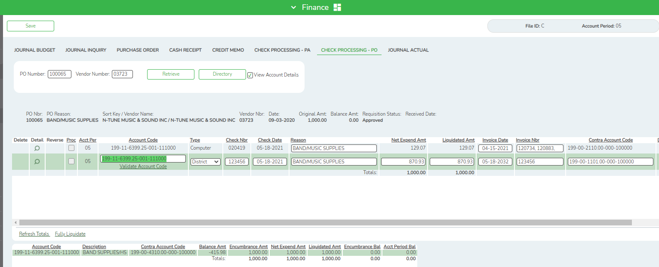

___ 8 In the Invoice Date field, type the date of the invoice being paid by this transaction.

___ 9 In the Invoice Nbr field, type the invoice number being paid by this transaction. The system verifies that the vendor and invoice number combination does not exist in another PO/PA in the logged-on file ID or in a previous file ID. If the system finds a duplicate transaction, a warning message is displayed.

___ 10 In the Contra Account Code field, the system automatically defaults to the payable object/subobject account in the District Finance Options > Clearing Fund Maintenance page with the same fund number and fiscal year as the account number that monies are being expended against. The user may modify the contra account for a district check (it cannot be modified for a computer check); however, the fund and fiscal year must be the same as the account number. The function code must be 00, and the object code must be 1XXX. Once the Contra Account field has been saved, it cannot be modified.

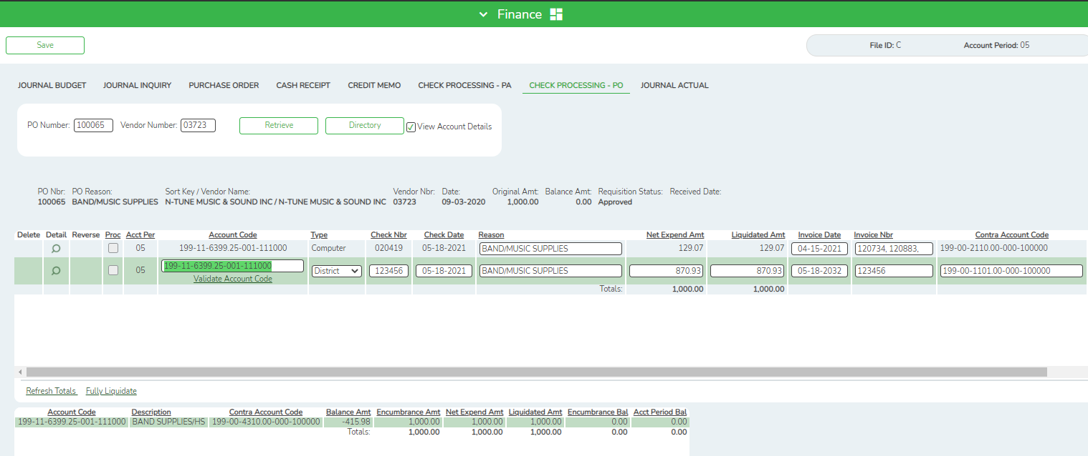

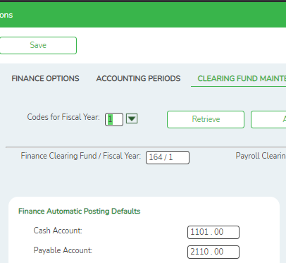

___ 11 In the Due Date field, this date represents the date that the check is to be processed. The field is automatically populated with the current system date if the district has selected "D - Use Due Date for Payables" on the District Options page. This field may be left blank if Use Due Date for Payables is not being utilized.

Note: If the user has selected "D - Use Due Date for Payables" for the Payables Date Used option on the District Options page, the system uses this date to determine whether it is time to print a check for the selected transaction. If the due date is within the range that the user listed on the Process Check page, or if the range is left blank, the check is printed. Otherwise, the transaction is retained until the due date is within the requested range. If the user changes the Payables Due Date option to "T - Use Transaction Date for Payables," the check is printed during the next check process.

___ 12 Select EFT to disburse the payment via an electronic funds transfer. By default, the field is automatically selected if the retrieved vendor has bank information listed on the Maintenance > Vendor Information > Vendor Miscellaneous tab, and an EFT email address listed on the Maintenance > Vendor Information > Vendor Name/Address tab.

Note: The vendor must have bank information and an EFT email address on file to be eligible for an electronic funds transfer.

___ 13 The Print field is automatically selected when the transaction is created, and a check is printed, if the criteria for issuing the check (e.g., date or account balance) is met. The user can unselect the Print field, and the transaction is not processed when the checks are issued.

Note: If this field is not selected and end-of-month processing has occurred, the transaction is considered a deferred check transaction. When the user is ready to print the transaction, he must select Print. If date ranges are used as criteria for selecting checks for processing, the date of this transaction must be included in that selection criteria in order for it to be processed.
The user can verify all deferred checks by printing an Accounts Payable Listing (FIN1700). It is the only report in the system that prints both the due date and the entry dates. Other reports that would be helpful are the Expenditure and Liquidation Journal, the Capital Outlay Expenditure Report, the Check Register and Check Transaction Listing, and the Check Payment Listing.

___ 14 Select Separate Check if the user has a vendor that has multiple transactions and/or multiple purchase order transactions and the user needs a separate check for one (or more) transaction. When the Separate Check field is selected, the associated transactions are displayed as separate check items in the list of checks to be processed. When checks are processed, those transactions with the Separate Check field selected are issued separately. Check transactions that do not have the Separate Check field selected are grouped by the vendor number.

Example: There are three separate PO transactions for the same vendor. The first PO has two transactions, one of which has the Separate Check field selected and the other does not. The second PO has a transaction that does not have the Separate Check field selected. The third PO has a transaction that also does not have the Separate Check field selected. When checks are processed, two checks are issued: one for the transaction that had the Separate Check field selected and one for all the other transactions for that vendor.

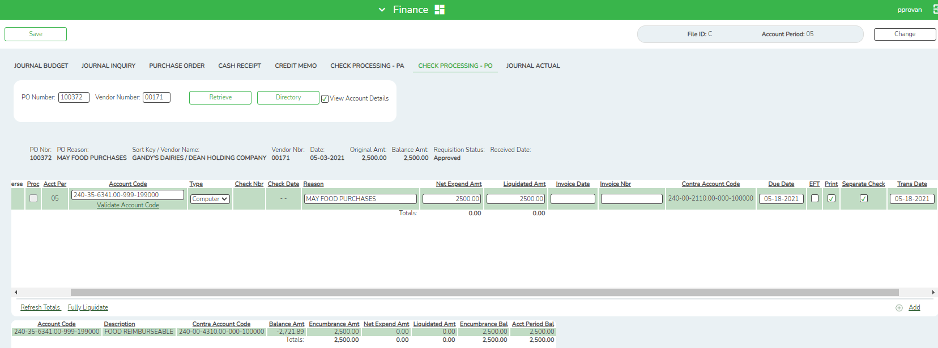

___ 15 The Trans Date field is set to the current system date. The user can modify this field, if the transaction has not been through end-of-month processing. If the transaction has been through end-of-month processing, the transaction date cannot be modified.

___ 16 Click Save.

